Terraform

- What is Terraform and why is it used?
Terraform is an open-source Infrastructure as Code (IaC) tool by HashiCorp for provisioning and managing infrastructure safely and efficiently across cloud and on-prem platforms.

- What are Terraforms main components?
Providers (cloud/platform APIs), Resources (infrastructure pieces), Modules (reusable templates), State (tracks resource mapping), Configuration files (written in HCL).

- What are some useful Terraform commands?
Terraform init , terraform plan, terraform apply, terraform destroy, terraform output, terraform state, terraform validate, terraform graph

- How does Terraform ensure impotency?
It compares current state with configuration and only makes necessary changes; running terraform plan helps visualize this

- How do you manage Terraform state in a team?
Use remote backends (like AWS S3 with DynamoDB locking or Terraform Cloud) for state sharing, locking, and versioning to prevent conflicts.

- How do modules improve Terraform usage?
They enable reuse, standardization, and maintainable code by encapsulating resource configurations.

- What does "Infrastructure as Code" (IaC) mean?
IaC is the process of managing and provisioning computing infrastructure through machine-readable configuration files, rather than physical hardware configuration or interactive configuration tools.

- What are Terraform Providers and why are they important?
Providers are plugins that enable Terraform to work with various platforms (e.g., AWS, Azure, Google Cloud, databases, and SaaS tools), managing resources specific to those services
- What is a Terraform State file? Why is it needed?
State files track the mapping between resources defined in the configuration and their real-world infrastructure counterparts, allowing Terraform to manage and update resources efficiently.

- What are Terraform Modules and how do they improve reusability?

Modules are reusable containers for multiple resources that can be invoked with different parameters, enabling code reuse and better organization.

- What is a Terraform Backend?
Backend determine how state is loaded and how operations are executed, supporting options like local files or remote storage (e.g., AWS S3, Terraform Cloud) for shared and secure state management.

- How does Terraform ensure idempotency?
Terraform compares the actual and desired states of resources, ensuring that repeated executions yield the same results unless the configuration changes.

- Describe the core workflow steps in Terraform

Terraform works by managing infrastructure as code through a series of well-defined steps, enabling reproducible and automated deployment of cloud and on-premises resources.​
Core Terraform Workflow
Write: Define the infrastructure using human-readable configuration files (usually in HCL), describing resources like virtual machines, networks, and databases.​
Init: Run terraform init to initialize the working directory, download required provider plugins, and set up backend configurations.​
Validate: Use terraform validate to check configuration syntax and structure before proceeding.​
Plan Creates and displays an execution plan, detailing actions to update infrastructure to match the configuration. Essential for reviewing proposed changes before deployment.​.​
Apply: Executes the actions defined in the plan, creating or updating cloud resources as specified in the code.​

Review and Iterate: Validate infrastructure functioning, iterate by adjusting configurations and repeating the process as needed.​
Destroy: Use terraform destroy to safely tear down managed resources when no longer needed, permanently deleting them from the environment.​
State Management
Terraform maintains a state file that tracks the current infrastructure, enabling efficient updates and collaboration. This file should be secured and, for teams, stored remotely for consistency.
​
Provider Plugins
Terraform relies on provider plugins to interact with various platforms (AWS, Azure, GCP, etc.), enabling resource management via API calls.​
This standardized workflow allows for increased automation, version control, and collaboration in infrastructure management.

terraform fmt:
Rewrites configuration files to standard formatting for readability and best practices.

Advanced Terraform Commands with Examples

- Terraform import
The terraform import command helps you take control of infrastructure resources that were created outside of Terraform (like manually in the cloud console) and bring them into Terraform's management. It does this by adding those resources to Terraform's state file, so Terraform knows about them and can manage them going forward without recreating anything.
You just need to tell Terraform the name you use for the resource in your Terraform code and the unique ID of the existing resource in the cloud. After that, Terraform tracks the resource just like anything else you create with code.
In simple terms: it connects Terraform to resources you already have, so you can manage everything consistently using Terraform without messing up the existing setup.

terraform import <resource_address> <resource_id>

Example: Importing an AWS EC2 instance with ID i-abcd1234 into a Terraform resource declared as aws_instance.web_server:
terraform import aws_instance.web_server i-abcd1234

- terraform taint/untaint:

The terraform taint command marks a specific resource in Terraform's state as "tainted," meaning Terraform will destroy and recreate that resource during the next terraform apply. This is useful when a resource becomes faulty or needs to be refreshed, but you don't want to change the whole infrastructure.
For example, if an AWS EC2 instance is misbehaving due to configuration or external changes, running:

The complementary command terraform untaint removes this tainted mark if you change your mind, so Terraform treats the resource normally again.
Key points:
terraform taint forces resource recreation without changing configuration files.
It is useful for fixing corrupted or outdated resources.
terraform untaint cancels the taint mark if a replacement is no longer needed.
Note: In newer Terraform versions, using terraform apply -replace="resource_name" is recommended for more visibility in plans.
This mechanism helps maintain infrastructure health by selectively renewing problematic resources without affecting others.

- Terraform workspace
It is a feature that lets you manage multiple separate environments using the same Terraform configuration files. Each workspace has its own state file, which keeps track of the resources it manages. This allows you to isolate infrastructure environments such as development, staging, and production without duplicating your code.
Key points about Terraform workspace:
It helps maintain environment isolation by managing different states for each workspace.
You can switch between workspaces to manage different environments easily.
Workspaces reduce code duplication since the same Terraform configuration can be used for all environments.
By default, Terraform starts in a workspace called "default."

Commands to manage workspaces include:
terraform workspace new <name> — create and switch to a new workspace.
terraform workspace select <name> — switch to an existing workspace.
terraform workspace list — list all workspaces.
terraform workspace delete <name> — delete a workspace (except "default").

- terraform state

The terraform state command is a set of subcommands for advanced manipulation and inspection of the Terraform state file. These commands allow managing the state directly to handle complex or special situations without editing the state file manually.

Key subcommands with explanations:
terraform state list
Lists all resources tracked in the current Terraform state. This helps quickly see which resources Terraform manages.
terraform state mv
Moves or renames a resource in the state file without recreating it. Useful for refactoring resource names or moving resources between modules or states.
terraform state rm
Removes a resource from the state file, essentially unmanaging that resource in Terraform without deleting the actual resource in the cloud.
terraform state show
Shows detailed attributes and metadata of a specific resource from the state file, similar to inspecting its current info.
These commands help with troubleshooting, state reorganization, and fine-tuning infrastructure management when normal terraform plan and terraform apply commands aren't enough.
Terraform automatically creates backup files before any state changes to prevent accidental data loss.
Use these commands carefully, especially in collaborative or production environments, to avoid unintended consequences.

These commands help with troubleshooting, state reorganization, and fine-tuning infrastructu
Examples:
List all managed resources:
text
terraform state list
Move a resource from one name to another:
text
terraform state mv aws_instance.old_name aws_instance.new_name
Remove a resource from state management:
text
terraform state rm aws_instance.unwanted_resource
Show details of a resource:
text
terraform state show aws_instance.web_server
This advanced state command set allows precise control over Terraform's understanding of infrastructure resources.tomatically creates backup files before any state changes to prevent accidental data loss.
Use these commands carefully, especially in collaborative or production environments, to avoid unintended consequences.

- Terraform console
command opens an interactive shell where users can evaluate and test Terraform expressions, functions, and variables in real time. It is useful for experimenting with interpolation syntax, testing built-in functions, inspecting resource attributes, and querying values from the current Terraform state without applying any changes.
Key Uses of terraform console:
Test Terraform expressions before adding them to configuration files.
Explore and debug variable values, outputs, and resource attributes.
Understand how Terraform functions behave with different inputs.
Interactively experiment with both configuration and state data.

- Terraform output
The terraform output command is used to display the value of output variables defined in your Terraform configuration. Outputs typically provide important information about the managed infrastructure, such as IP addresses, DNS names, or resource IDs, which can be used by other tools, scripts, or users.
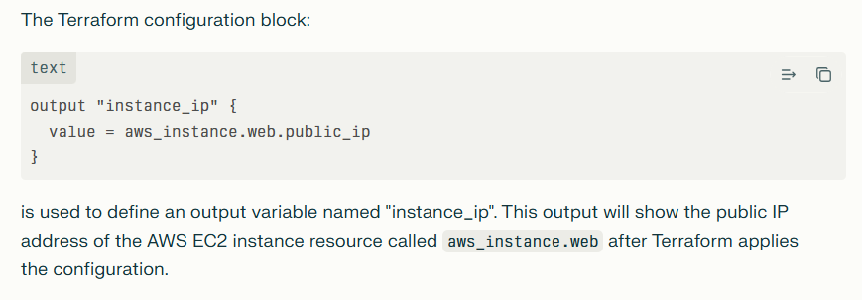
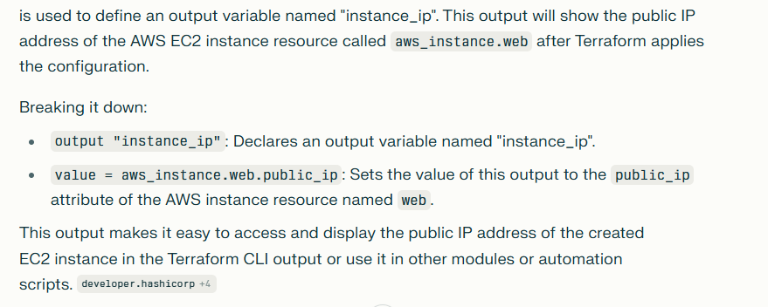
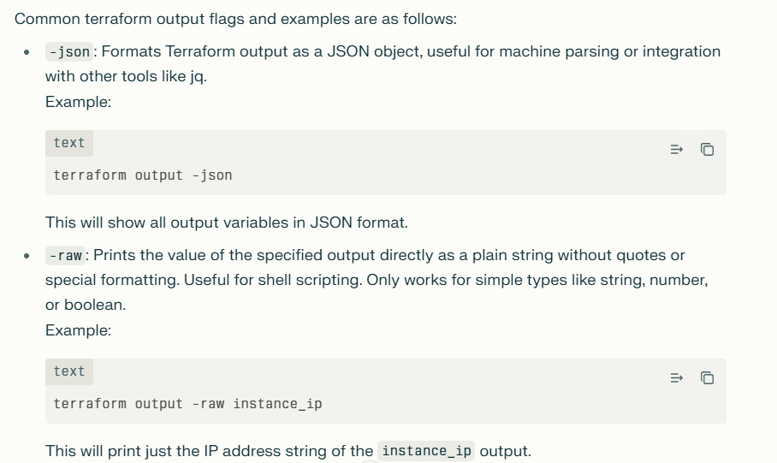
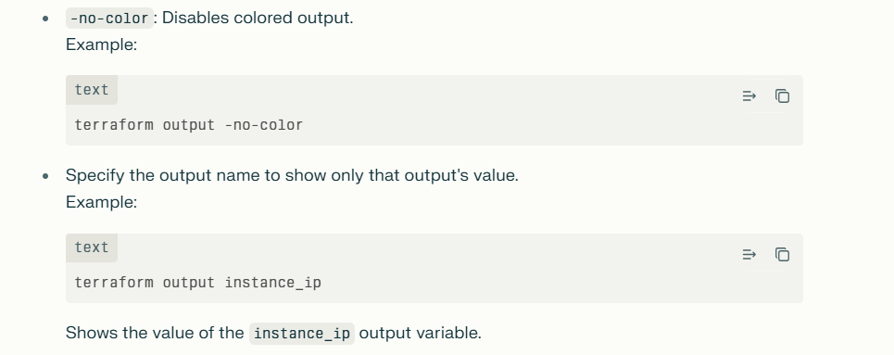

- terraform show

The terraform show command displays the contents of a Terraform state or plan file in a human-readable format. It lets you inspect the current state of your infrastructure as Terraform understands it, or review a saved execution plan to verify which changes will be applied.

terraform show -no-color tfplan > tfplan.txt'

Terraform module

A Terraform module is simply a folder with related Terraform configuration files that work together to create a part of your infrastructure. It’s like a reusable recipe for building resources. Instead of writing the same code over and over, you write it once as a module and use it multiple times.
Every Terraform setup is a module — the main folder you work in is called the root module. If you include other modules inside it, those are called child modules. This way, you can organize your infrastructure in smaller pieces, making it easier to manage and reuse code.

Example 1: terraform code to create VPC

provider "aws" {
region = "eu-north-1"
}

resource "aws_vpc" "main"{
cidr_block = "16.0.0.0/16"
tags = {
Name = "vpc_by_terraform"
}
}

resource "aws_subnet" "public"{
vpc_id = aws_vpc.main.id
cidr_block = "16.0.0.0/17"
availability_zone = "eu-north-1a"
tags = {
Name = "subnet_by_terraform"
}
}

resource "aws_internet_gateway" "igw"{
vpc_id =aws_vpc.main.id
tags = {
Name = "internet_by_terraform"
}
}

resource "aws_route_table" "traffic"{
vpc_id =aws_vpc.main.id
route{
cidr_block = "0.0.0.0/0"
gateway_id = aws_internet_gateway.igw.id
}
tags = {
Name = "route_table_by_terraform"
}
}

resource "aws_route_table_association" "pub"{
subnet_id=aws_subnet.public.id
route_table_id= aws_route_table.traffic.id
}
}
Example 2: Terraform code to create EC2

provider "aws" {
region = "eu-north-1"
}
resource "aws_instance" "ec2" {
ami = "ami-02ec57994fa0fae21"
instance_type = "t3.micro"
key_name = "awsterraformkey"
subnet_id = aws_subnet.public.id
associate_public_ip_address = true
user_data = file("script.sh")

root_block_device {
volume_size = 16
volume_type = "gp2"
delete_on_termination = true
}

tags = {
Name = "Ec2_by_terraform"
}
}
output "instance_public_ip" {
value = aws_instance.ec2-machine.public_ip
}

Example 3: terraform code to create S3

provider "aws" {
region = "us-east-1"
}
resource "aws_s3_bucket" "my_bucket" {
bucket = "my-unique-bucket-name"
acl = "private"
tags = {
Name = "MyS3Bucket"
Environment = "Production"
}
}
Explanation:
The provider block configures the AWS provider with the desired region.
The aws_s3_bucket resource block creates the S3 bucket with a unique name.
The acl is set to "private" for restricted access.
Tags are optional but useful for identification.

Example 4: terraform code to create RDS

provider "aws" {
region = "us-east-1"
}
resource "aws_db_instance" "mydb" {
allocated_storage = 20
engine = "mysql"
engine_version = "8.0"
instance_class = "db.t3.micro"
name = "mydatabase"
username = "adminuser"
password = "adminpassword"
parameter_group_name = "default.mysql8.0"
skip_final_snapshot = true
tags = {
Name = "MyRDSInstance"
}
}

Explanation:
provider block sets the AWS region.
aws_db_instance resource creates the RDS instance.
allocated_storage sets disk size in GB.
engine and engine_version specify the database engine.
instance_class defines the instance size.
name is the initial database name.
username and password define the master user credentials.
skip_final_snapshot set to true allows easy destruction during testing.
Tags provide identification metadata.
After saving this code to a .tf file, run terraform init, then terraform apply to provision the RDS instance on AWS. Replace usernames, passwords, and region values as needed.
This is a standard approach to create an RDS instance with Terraform

Example 5:-

Jenkins Pipeline Script (Declarative)

pipeline
{
agent any
environment
{
AWS_REGION = 'us-east-1'
TF_VAR_instance_name = 'my-ec2-instance'
}
stages
{
stage('Checkout')
{
steps
{
// Checkout your Terraform code repository
git 'https://github.com/your-repo/terraform-ec2.git'
}
}
stage('Terraform Init')
{
steps
{
sh 'terraform init'
}
}
stage('Terraform Plan')
{
steps
{
sh 'terraform plan -out=tfplan'
}
}
stage('Terraform Apply')
{
steps
{
sh 'terraform apply -auto-approve tfplan'
}
}
}
post
{
always
{
echo 'Cleaning up workspace'
cleanWs()
}
}
}

Explanation of the Jenkins Pipeline Script
This is a Declarative Jenkins Pipeline that automates the process of provisioning AWS EC2 infrastructure using Terraform.
pipeline {}: The root block defining the pipeline.
agent any: Tells Jenkins to run the pipeline on any available executor node.
environment {}: Sets environment variables for the pipeline execution—here it defines:
AWS_REGION as us-east-1 (the AWS region where resources are created).
TF_VAR_instance_name as my-ec2-instance (a Terraform variable used in the Terraform code).
stages {}: Contains the sequential stages of the pipeline, each performing a logical step.
Checkout stage:
Checks out the Terraform code repository from Git to the Jenkins workspace.
Terraform Init stage:
Runs terraform init to initialize the Terraform working directory, downloading required providers and modules.
Terraform Plan stage:
Runs terraform plan -out=tfplan to create an execution plan and save it to a file (tfplan). This step previews changes Terraform will apply.
Terraform Apply stage:
Runs terraform apply -auto-approve tfplan to apply the changes from the Terraform plan without asking for confirmation.
post { always { ... } }: A block that runs after the pipeline finishes, regardless of success or failure. Here it:
Prints a message.
Cleans up the Jenkins workspace to free disk space and avoid leftover files.

Example 6:- pipeline script to create resource. Versioning the terraform code using git and Jenkins. We can create the resource using pipeline as soon as we make the change it will create the resource.
pipeline
{
Parameters
{
choice(name :'terraformaction' choice :['apply','destroy'],description:',choose the terraform action')
}
Environment
{

AWS_ACCESS_KEY_ID = credentials('AWS_ACCESS_KEY_ID')
AWS_SECRET_ACCESS_KEY_ID = credentials('AWS_SECRET_ACCESS_KEY_ID')
}
agent any
stages
{
stage('checkout')
{
steps
{
git branch:'main',url:'https://github.com/MYPROJECTS555/terraform_project.git'
}
}
}
stage ('plan')
{
steps
{
sh '''
cd project-3/
terraform init
terraform plan -out tfplan
terraform show -no-color tfplan > tfplan.txt
'''
}
}
stage ('approval')
{
script
{
def plan = readFile 'project-3/tfplan.txt'
input message: "do you want to proceed with terraform action "
parameters: [text(name: 'plan',description : 'please review the plan', defaultvalue : plan)]

}
}
stage('Apply or Destroy')
{
when
{
expression
{
return params.terraformAction == 'apply' || params.terraformAction == 'destroy'
}
}

steps
{
Script
{
if (params.terraformAction == 'apply')
{
echo "terraform apply is running"
sh '''
cd project/
terraform apply -input=false tfplan
'''
}
else if (params.terraformAction == 'destroy')
{
echo "terraform destroy is running"
sh '''
cd project/
terraform destroy -auto-approve
'''
}
}
}
}
}
--------------------------------------------------------------------------------------------

- What is the difference between a Terraform state file and its state file backup?

Terraform State File
The primary state file is usually named terraform.tfstate and contains the latest snapshot of your infrastructure as managed by Terraform.​
Terraform uses this file to track resource attributes, metadata, and relationships, allowing it to plan and apply updates accurately without recreating existing resources.​
Every time you run terraform apply, the state file is updated to reflect the current infrastructure state.

State File Backup
The backup file is typically named terraform.tfstate.backup and is automatically created by Terraform before any changes are made to the main state file.​
Its role is to serve as a safety net, allowing recovery if the main state file becomes corrupted, lost, or if an operation fails.​
The backup is overwritten with each new Terraform operation, always retaining the immediately previous state.​
Restoration involves renaming the backup file to terraform.tfstate and reinitializing Terraform, which reverts your infrastructure to its previous known state at the time the backup was made.
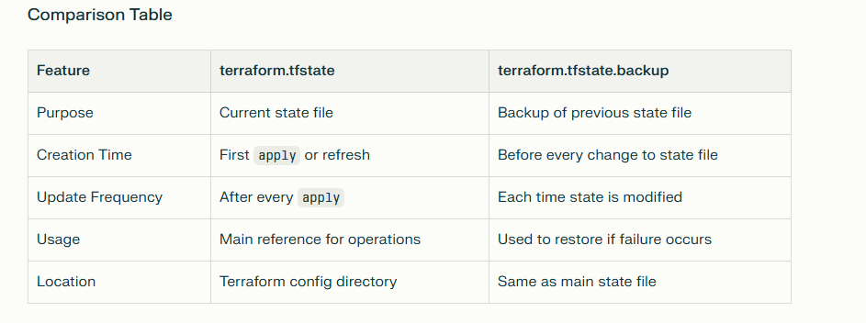

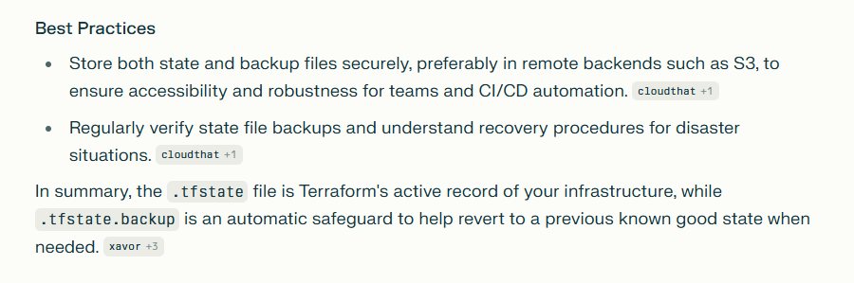

- Explain how you would manage secrets securely with Terraform (for example, without hardcoding them in .tf files

Use sensitive variables and pass secret values through environment variables or separate variable files excluded from version control.
Integrate Terraform with external secret managers like AWS Secrets Manager or HashiCorp Vault to fetch secrets dynamically at runtime.
Store Terraform state files securely in remote backends with encryption and access controls since state may contain sensitive data.
Mark outputs with secrets as sensitive to avoid displaying them in logs or UI.
Avoid putting secrets directly in code or state files to prevent exposure or leaks.

- How do you implement multi-environment (dev, staging, prod) deployments using Terraform workspaces?

Terraform workspaces allow multiple isolated states using the same configuration.
Create a workspace for each environment: dev, staging, prod using terraform workspace new.
Switch between environments with terraform workspace select <name>.
Use terraform.workspace in configs to customize resources per environment.
For example, adjust instance size or count based on workspace.
Each workspace stores its own state file keeping environments separate.
This avoids duplicating infrastructure code for each environment.
Apply and plan commands run in the context of the selected workspace.
This supports consistent, isolated deployments for multiple environments.
Workspaces simplify managing lifecycle and state separately for dev, staging, and prod.

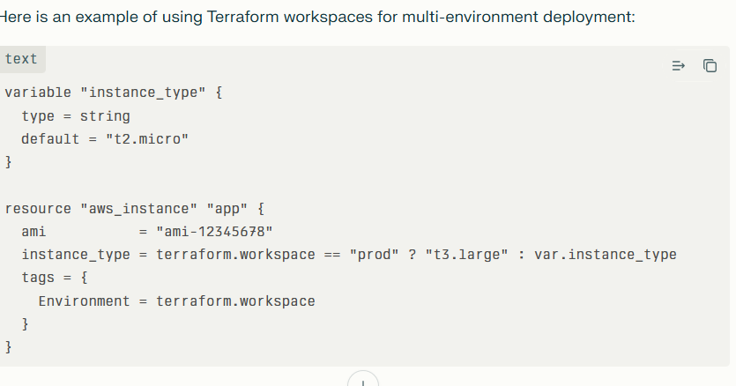
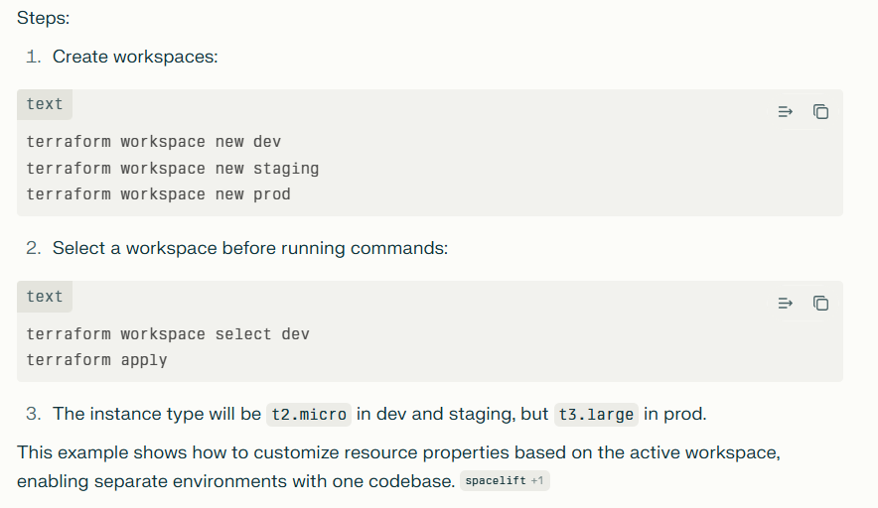

What troubleshooting steps do you follow if a terraform apply fails due to dependency or resource issues

Read the error message carefully to understand which resource failed and why.
Run terraform plan to see what changes Terraform intends to make and spot conflicts.
Use terraform graph to visualize resource dependencies and check for circular references.
List resources in the state with terraform state list and examine details with terraform state show <resource>.
Run terraform refresh to update the state with the actual infrastructure status.
Check if provider API limits, permissions, or quotas are causing resource creation failures.
Manually verify the dependent resources outside Terraform to ensure they exist and are correct.
If needed, remove problematic resources from the state using terraform state rm or mark them for recreation using terraform taint.
Validate your Terraform configuration for syntax or logical errors using terraform validate.
After corrections, retry terraform apply.

- How would you recover from a corrupted state file? What best practices do you follow for Terraform state management?
To recover from a corrupted Terraform state file:
Restore from the latest backup file (rename terraform.tfstate.backup to terraform.tfstate and re-run terraform init).
If using remote backends (like AWS S3), restore the state file from version history, or download a previous healthy version and upload it as the current state.
If you have no backup, you may need to manually re-import existing infrastructure into a fresh state file using terraform import.
For remote backends, monitor versioning and enable automatic state file backups for easy rollbacks.
Use terraform state pull to get the current state, and terraform state push to update if needed.

Best practices for Terraform state management:
Always use remote backends (like S3 with versioning, Terraform Cloud, or Azure Blob Storage) for centralized, team-friendly, and resilient state storage.
Enable encryption and secure access controls on the state file storage to protect sensitive data.
Keep separate state files for each environment (dev, staging, prod) to prevent accidental cross-environment updates.
Regularly backup and test recovery of state files to ensure you can restore quickly during emergency.
Avoid manual modifications of state files; use Terraform commands for all state changes.
Keep sensitive information out of state files where possible, and use external secret managers.
Document and automate state management procedures in your team for consistency and quick troubleshooting.
- Can you explain the difference between a data source and a resource in Terraform?

Resource:-

A resource in Terraform is used to create, update, or delete infrastructure components like VMs, databases, or networks—resources are actively managed by Terraform and represent the infrastructure Terraform provisions.
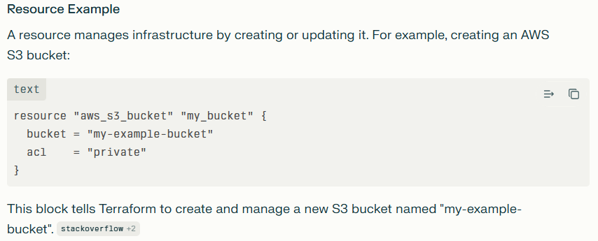

Data source:-

A data source, on the other hand, is used to fetch or read information about existing infrastructure or external systems without managing them—data sources are read-only and are often used to reference data about infrastructure created outside of Terraform or by other teams.

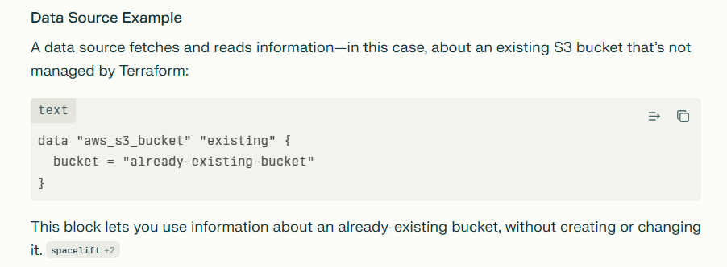

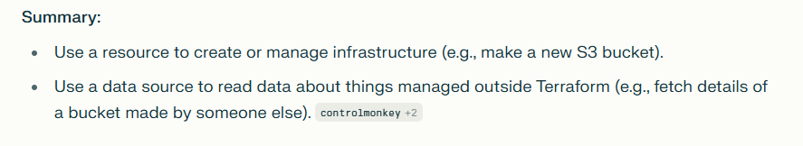
- What are some best practices for using modules and remote backends in large teams and CI/CD pipelines?

For Modules:-
Keep modules focused on a single purpose (e.g., networking, compute) to enhance reusability and maintainability.​
Define clear input variables and output values to make modules flexible and composable.​
Establish a standard directory structure (e.g., main.tf, variables.tf, outputs.tf, README.md) for consistent organization across teams.​
Document every module thoroughly with usage instructions for easier team adoption.​
Use semantic versioning for modules and pin versions to prevent breaking changes in dependencies.​
Test modules independently before integrating them into larger stacks, using tools like Terratest or terraform validate.​
Avoid circular dependencies—use data sources for cross-module references if needed.​
Publish common modules to a private or public registry for discoverability and sharing across projects.

For Remote Backends

Always use a remote backend (such as AWS S3, Azure Blob Storage, or Terraform Cloud) for storing state files to enable team collaboration and prevent state conflicts.​
Enable state locking (e.g., DynamoDB with S3) to avoid concurrent modification issues when multiple users or CI jobs run applies at the same time.​
Set up backup and versioning for state files so you can restore if corruption or accidental deletion occurs.​
Use encryption and strict access control policies to secure remote state, as it may contain sensitive values.​
Separate backend configuration for each environment (dev, staging, prod) to avoid cross-environment interference.​
Monitor remote state activity to track and audit changes in CI/CD processes.​
Avoid manual changes to state files—always use Terraform commands and workflows for modifications.

For CI/CD Pipelines:
Always run terraform plan and proper policy checks automatically to catch issues before deployment; use tools like tflint, pre-commit hooks, and static analysis.​
Use version control for Terraform configurations and modules, enforcing code reviews before merging changes.​
Automate module usage enforcement so teams use standardized modules from approved sources.​
Prepare build environments with all necessary plugins and credentials ahead of deployment for consistent results.​

- How do you securely manage provider credentials in automation contexts like CI/CD?
securely manage provider credentials in CI/CD automation:
Avoid hardcoding credentials in Terraform configuration files or pipeline scripts.
Store credentials securely in secret management systems like AWS Secrets Manager, HashiCorp Vault, Azure Key Vault, or CI/CD platform secrets stores.
Inject credentials into the CI/CD pipeline as environment variables or use secret injection features of the pipeline tool.
Use short-lived and least-privilege credentials (e.g., IAM roles with minimal permissions, temporary tokens) for better security.
Encrypt credentials at rest and in transit within your pipeline and backend storage.
Limit access to credentials through strict role-based access control (RBAC) and audit access regularly.
Rotate credentials regularly and automate rotation if possible.
Use Terraform provider-specific authentication methods such as instance profiles, managed identities, or OIDC-based authentication to avoid managing static secrets.
Validate that credentials are not exposed in pipeline logs or outputs by marking them as sensitive.
Test your CI/CD pipeline for secret leaks as part of security scanning.

- How do you configure and authenticate Terraform with AWS or Azure?​

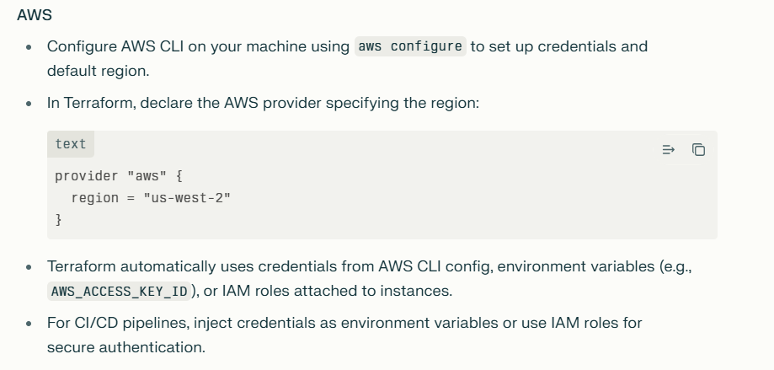

Note: how the terraform code will move to different environment.
Simple idea
Keep one common codebase (or shared modules).​
Have separate envs (dev, stage, prod) using:
Either workspaces: terraform workspace select dev|stage|prod + different *.tfvars.​
Or folders: env/dev, env/stage, env/prod each calling the same modules with different variables.​
Promotion flow
Change code → apply to dev → test → then run the same code for stage → then prod (usually via CI/CD with approvals).

Terraform workspace
Terraform workspaces let you manage multiple environments (dev, stage, prod) from one codebase by creating separate state files for each. in detail and example for begiinner point of view
Terraform workspaces help beginners manage multiple environments (like dev, stage, prod) using just one folder of Terraform code instead of copying files everywhere.​
Simple Analogy
Think of workspaces as separate notebooks for the same class notes:
Your .tf files = the class notes (shared for all envs)
Each workspace = a notebook tracking only its own homework (dev resources don't see prod resources)

Terraform modular concepts
Modular Terraform code breaks infrastructure into reusable modules for each component, like VPC or EC2.
Core Benefits
Reusability: Call the same module multiple times with different variables for dev/prod environments.
Simplicity: Hide complex details behind simple inputs/outputs.
Maintainability: Update one module, affects all environments consistently.

Module/
├── main.tf # Resources and provider configs
├── variables.tf # Input parameters
├── outputs.tf # Exposed values
└── versions.tf # Provider constraints

Main purpose of the terraform modules
For example: we have write the terraform code which include vpc ec2 etc.
If we want to make a changes we have to change entire code of terraform just like monolithic application, that’s why we use moduler in terraform.
Previously we used to write all the code in main.tf. It is very difficult to identify the bug.

The advantage of using Terraform modules in your infrastructure as code (IaC) projects lies in improved organization, reusability, and maintainability. Here are the key benefits:
- Modularity: Terraform modules allow you to break down your infrastructure configuration into smaller, self-contained components. This modularity makes it easier to manage and reason about your infrastructure because each module handles a specific piece of functionality, such as an EC2 instance, a database, or a network configuration.
- Reusability: With modules, you can create reusable templates for common infrastructure components. Instead of rewriting similar configurations for multiple projects, you can reuse modules across different Terraform projects. This reduces duplication and promotes consistency in your infrastructure.
- Simplified Collaboration: Modules make it easier for teams to collaborate on infrastructure projects. Different team members can work on separate modules independently, and then these modules can be combined to build complex infrastructure deployments. This division of labor can streamline development and reduce conflicts in the codebase.
- Versioning and Maintenance: Modules can have their own versioning, making it easier to manage updates and changes. When you update a module, you can increment its version, and other projects using that module can choose when to adopt the new version, helping to prevent unexpected changes in existing deployments.
- Abstraction: Modules can abstract away the complexity of underlying resources. For example, an EC2 instance module can hide the details of security groups, subnets, and other configurations, allowing users to focus on high-level parameters like instance type and image ID.
- Testing and Validation: Modules can be individually tested and validated, ensuring that they work correctly before being used in multiple projects. This reduces the risk of errors propagating across your infrastructure.
- Documentation: Modules promote self-documentation. When you define variables, outputs, and resource dependencies within a module, it becomes clear how the module should be used, making it easier for others (or your future self) to understand and work with.
- Scalability: As your infrastructure grows, modules provide a scalable approach to managing complexity. You can continue to create new modules for different components of your architecture, maintaining a clean and organized codebase.
- Security and Compliance: Modules can encapsulate security and compliance best practices. For instance, you can create a module for launching EC2 instances with predefined security groups, IAM roles, and other security-related configurations, ensuring consistency and compliance across your deployments.
:
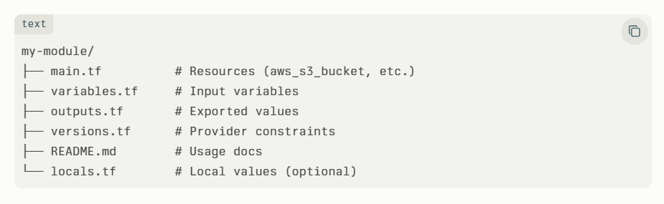
File | One-Word Purpose
main.tf | Resources
variables.tf | Inputs
outputs.tf | Exports
versions.tf | Constraints

terraform.tfvars - Optional File
terraform.tfvars is not required because Terraform supports multiple variable input methods. Default values in variables.tf make it unnecessary.

Root Module Only Structure
Simple deployments keep all resources in single main.tf. No module overhead suits prototyping your EKS node groups.

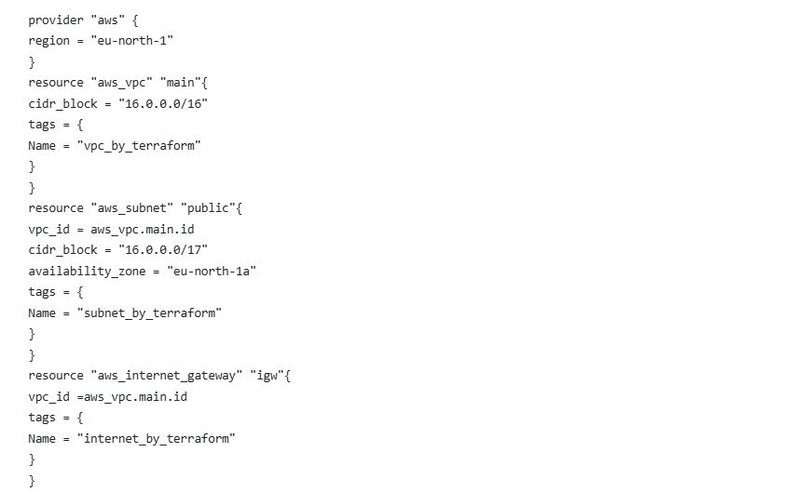
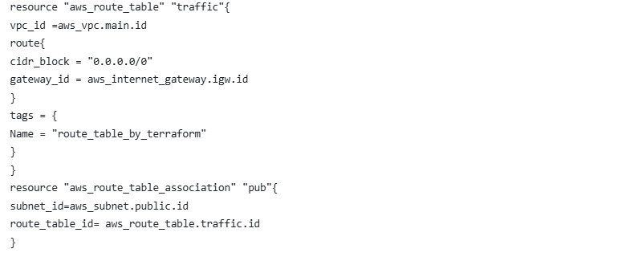

Nested Modules Structure
Root orchestrates reusable child modules with explicit dependencies.
For example
